SE 4485: Software Engineering Projects

Fall 2026

Detailed Design Documentation

Group Number | 9
Project Title | Skills Catalog & Inventory (Team A)
Sponsoring Company | Sabre Corporation
Sponsor(s) | Jeff Buchmiller
Students | 1.Tobenna Nwosu  2. Jason Lehman  3. Alice Askerup  4. Russel Costales  5. Kim Chau  6. Jasmine Shrestha

Skills Catalog & Inventory

- ABSTRACT
This is the Detailed Design Documentation for the Skills Catalog & Inventory project sponsored by Sabre Corporation. This project is one of the ten projects for this course SE 4485.001 at the University of Texas at Dallas. This document complies with the Software Engineering Standards set by the IEEE Standard for Software Project Management Plans (IEEE Std 1058-1998). The document sets the architectural design and structure for the project.

B. TABLE OF CONTENTS

Abstract……………………………………………………………………………………….…....3
- Table of Contents…………………………………………………………………………….…….4
- List of Figures……………………………………………………………………………………...5
- List of Tables………………………………………………………………………………….……5
- Introduction……………………………………………………………………………….….…….
1.1. Introduction to the document…………………………………………………………….……
1.2. Purpose and Scope of the document…………………………………………………….….…
1.3. Description of the structure of the document………………………………………….………
- GUI (Graphical User Interface) Design
- Static Model
- Dynamic Model
- Rationale for your Detailed Design Model
- Traceability from Requirements to Detailed Design Model
- Evidence the Design Model has been placed under configuration
- Engineering Standards and Multiple Constraints
- Additional References

LIST OF FIGURES

LIST OF TABLES

1. INTRODUCTION

1.1 Introduction to the entire document
The Detailed Design Documentation describes the design details of the Skills Catalog & Inventory (Team A) project. This document provides an overview of the system’s architecture, structure, and the interactions between different components. This document serves as a guide for the team to develop the system by explaining how the system’s requirements will be translated into a detailed design that supports implementation.

1.2 Purpose and scope of the document
The purpose of this Detailed Design Document is to describe the system’s internal structure, user interface design, and interactions between components for the Skills Catalog and Inventory application. It translates the functional and non-functional requirements into a detailed technical design that will guide the implementation, testing, and integration of the system's components. This document will include class diagrams to visually represent the system's classes, attributes, methods, and relationships. The document will also include GUI diagrams to outline the layouts, navigation, and interactive elements of the user interface for each stakeholder role. Sequence diagrams will also be included to demonstrate the order of interaction between users, system components, and the database during key operations. This document and diagrams will serve as a technical reference for the development team to ensure that the system’s architecture and user experience align with the outlined functional and non-functional requirements

1.3 Description of the structure of the document
This Detailed Design Document bridges the gap between the requirements and how it is implemented. The document is organized into the following sections:
- Introduction: Introduces the document while explaining its purpose and scope.
- GUI (Graphical User Interface) Design: Presents the GUI design of the Skills Catalog and Inventory.
- Static Model: Presents the static model of the system using UML class diagrams to show the classes, their attributes and operations, and the relationship among them.
- Dynamic Model: Presents the dynamic model of the system using UML sequence diagrams to show how objects interact over time.
- Rationale for the detailed design model: Gives the rationale for detailed design model while explaining the design decisions, alternatives considered, and the patterns and principles applied.
- Traceability from requirements to detailed design model: Maps requirements in Requirements Documentation to design elements that satisfy it.
- Configuration management: Links to relevant repository management tools.
- Engineering Standards and Multiple Constraints: Lists the industry standards guiding the project.
- Glossary and Additional References: Defines key terms and provides supporting references.

2. GUI (Graphical User Interface) Design
- screen designs (coded or using drawing tool)

https://www.figma.com/site/4MErdkV6ukx8CgcgEeqLpP/GUI-Design?node-id=0-1&p=f&t=f6I4wJtNxJAzIoNx-0

3. Static Model: CLASS DIAGRAM (Captured in draw.io)
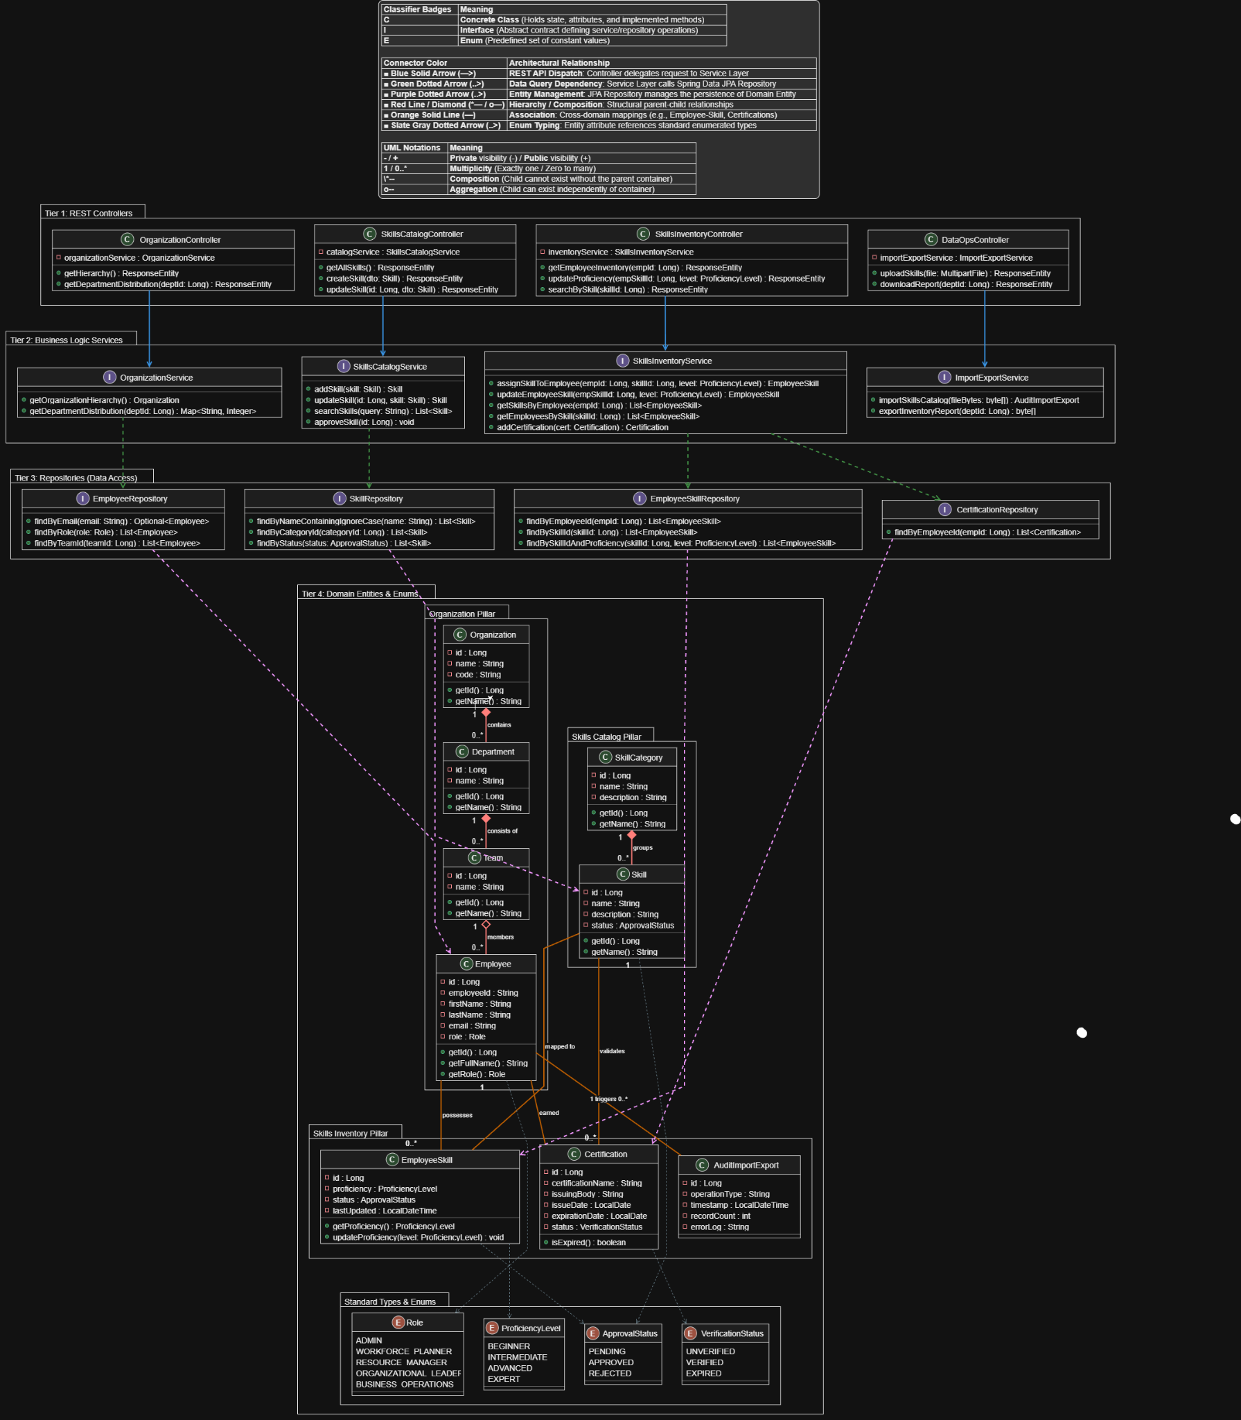

3.2 Tier Decomposition
- Tier 1: REST Controllers (API Layer)
  - Provides HTTP/REST endpoints connecting the React/TypeScript frontend to the backend application server.
  - Dispatches transport DTOs (Data Transfer Objects) and handle response entity encapsulation for all user interactions.
- Tier 2: Business Logic Services (Service Layer)
  - Implements enterprise business logic, validation rules, transactional integrity, and data transformation routines.
  - Serves as an abstraction layer between presentation endpoints and database persistence.
- Tier 3: Repositories (Data Access Layer)
  - Uses Spring Data JPA interfaces extending JpaRepository to abstract SQL operations against the PostgreSQL database.
  - Defines standard and custom query methods for personnel, skill catalog definitions, and inventory mappings.
- Tier 4: Domain Entities & Enums (Persistence Layer)
  - Comprises persistent JPA entity classes mapped to relational tables and enumerated types enforcing standardized domain values.
  - Organized into three domain pillars: Organization, Skills Catalog (Master Data), and Skills Inventory (Operational Data).

3.3 Detailed Class Specifications by Tier

Tier 1: REST Controllers
- OrganizationController [Class]
  - Attributes:
    - - organizationService : OrganizationService
  - Operations:
    - + getHierarchy() : ResponseEntity
    - + getDepartmentDistribution(deptId: Long) : ResponseEntity
- SkillsCatalogController [Class]
  - Attributes:
    - - catalogService : SkillsCatalogService
  - Operations:
    - + getAllSkills() : ResponseEntity
    - + createSkill(dto: Skill) : ResponseEntity
    - + updateSkill(id: Long, dto: Skill) : ResponseEntity
- SkillsInventoryController [Class]
  - Attributes:
    - - inventoryService : SkillsInventoryService
  - Operations:
    - + getEmployeeInventory(empId: Long) : ResponseEntity
    - + updateProficiency(empSkillId: Long, level: ProficiencyLevel) : ResponseEntity
    - + searchBySkill(skillId: Long) : ResponseEntity
- DataOpsController [Class]
  - Attributes:
    - - importExportService : ImportExportService
  - Operations:
    - + uploadSkills(file: MultipartFile) : ResponseEntity
    - + downloadReport(deptId: Long) : ResponseEntity

Tier 2: Business Logic Services
- OrganizationService [Interface]
  - Operations:
    - + getOrganizationHierarchy() : Organization
    - + getDepartmentDistribution(deptId: Long) : Map<String, Integer>
- SkillsCatalogService [Interface]
  - Operations:
    - + addSkill(skill: Skill) : Skill
    - + updateSkill(id: Long, skill: Skill) : Skill
    - + searchSkills(query: String) : List<Skill>
    - + approveSkill(id: Long) : void
- SkillsInventoryService [Interface]
  - Operations:
    - + assignSkillToEmployee(empId: Long, skillId: Long, level: ProficiencyLevel) : EmployeeSkill
    - + updateEmployeeSkill(empSkillId: Long, level: ProficiencyLevel) : EmployeeSkill
    - + getSkillsByEmployee(empId: Long) : List<EmployeeSkill>
    - + getEmployeesBySkill(skillId: Long) : List<EmployeeSkill>
    - + addCertification(cert: Certification) : Certification
- ImportExportService [Interface]
  - Operations:
    - + importSkillsCatalog(fileBytes: byte[]) : AuditImportExport
    - + exportInventoryReport(deptId: Long) : byte[]

Tier 3: Repositories (Data Access)
- EmployeeRepository [Interface]
  - Operations:
    - + findByEmail(email: String) : Optional<Employee>
    - + findByRole(role: Role) : List<Employee>
    - + findByTeamId(teamId: Long) : List<Employee>
- SkillRepository [Interface]
  - Operations:
    - + findByNameContainingIgnoreCase(name: String) : List<Skill>
    - + findByCategoryId(categoryId: Long) : List<Skill>
    - + findByStatus(status: ApprovalStatus) : List<Skill>
- EmployeeSkillRepository [Interface]
  - Operations:
    - + findByEmployeeId(empId: Long) : List<EmployeeSkill>
    - + findBySkillId(skillId: Long) : List<EmployeeSkill>
    - + findBySkillIdAndProficiency(skillId: Long, level: ProficiencyLevel) : List<EmployeeSkill>
- CertificationRepository [Interface]
  - Operations:
    - + findByEmployeeId(empId: Long) : List<Certification>

Tier 4: Domain Entities & Enums

Organization Pillar
- Organization [Class]
  - - id : Long
  - - name : String
  - - code : String
  - + getId() : Long
  - + getName() : String
- Department [Class]
  - - id : Long
  - - name : String
  - + getId() : Long
  - + getName() : String
- Team [Class]
  - - id : Long
  - - name : String
  - + getId() : Long
  - + getName() : String
- Employee [Class]
  - - id : Long
  - - employeeId : String
  - - firstName : String
  - - lastName : String
  - - email : String
  - - role : Role
  - + getId() : Long
  - + getFullName() : String
  - + getRole() : Role

Skills Catalog Pillar (Master Data)
- SkillCategory [Class]
  - - id : Long
  - - name : String
  - - description : String
  - + getId() : Long
  - + getName() : String
- Skill [Class]
  - - id : Long
  - - name : String
  - - description : String
  - - status : ApprovalStatus
  - + getId() : Long
  - + getName() : String

Skills Inventory Pillar (Operational Data)
- EmployeeSkill [Class]
  - - id : Long
  - - proficiency : ProficiencyLevel
  - - status : ApprovalStatus
  - - lastUpdated : LocalDateTime
  - + getProficiency() : ProficiencyLevel
  - + updateProficiency(level: ProficiencyLevel) : void
- Certification [Class]
  - - id : Long
  - - certificationName : String
  - - issuingBody : String
  - - issueDate : LocalDate
  - - expirationDate : LocalDate
  - - status : VerificationStatus
  - + isExpired() : boolean
- AuditImportExport [Class]
  - - id : Long
  - - operationType : String
  - - timestamp : LocalDateTime
  - - recordCount : int
  - - errorLog : String

Standard Types & Enums
- Role [Enum]: ADMIN, WORKFORCE_PLANNER, RESOURCE_MANAGER, ORGANIZATIONAL_LEADER, BUSINESS_OPERATIONS
- ProficiencyLevel [Enum]: BEGINNER, INTERMEDIATE, ADVANCED, EXPERT
- ApprovalStatus [Enum]: PENDING, APPROVED, REJECTED
- VerificationStatus [Enum]: UNVERIFIED, VERIFIED, EXPIRED

4. Dynamic Model
SEQUENCE DIAGRAMS
- captured in Rose (other tools are also allowed)

5. RATIONALE FOR YOUR DETAILED DESIGN MODEL
The rationale behind our detailed design model was to provide a clear representation of the Skills Inventory system’s architecture, components, and interactions. It translates the system requirements into a structured design by defining the responsibilities of individual classes and how they work together to support the system’s functionality. The separation of controllers, services, repositories, and entities promotes modularity by ensuring that each component has a set task to complete. Controllers manage incoming requests and coordinate operations, services handle business logic, repositories manage data access, and entities represent the system’s core information and relationships.
The design also establishes relationships between key entities such as Person, Skill, SkillCategory, and PersonSkill, allowing the system to organize skill information and associate skills with individuals. This structure supports operations such as creating and maintaining skills, searching for people based on their skills, managing person-skill associations, and retrieving organizational information. By defining these relationships and assigning responsibilities to specific components, the model provides a consistent approach to handling data and processing user requests.
Additionally, the detailed design promotes maintainability, reusability, and extensibility. Separating the system into distinct components makes it easier to modify or expand individual areas without unnecessarily affecting the rest of the application. For example, changes to skill-management operations can be handled within the relevant services and repositories while maintaining the overall structure of the system. The design also provides a foundation for understanding how the system’s components collaborate to fulfill user requirements and how the application can be implemented, tested, and maintained. Overall, the detailed design model establishes a logical and organized structure for the Skills Inventory system, connecting its data, business logic, and user-facing operations into a cohesive application.
6. TRACEABILITY FROM REQUIREMENTS TO DETAILED DESIGN MODEL
- provide a mapping between requirements and detailed design model
- clearly describe how each requirement in the Requirements Documentation is captured in the design

General / Business Operations Functional Requirements | Traces to Detailed Design Model
Import Skills Catalog | DataOpsController.uploadSkills(file) calls ImportExportService.importSkillsCatalog(fileBytes) to import the Skills Catalog data.
Load additional skills | SkillsCatalogController.createSkill(dto) calls SkillsCatalogService.addSkills(skill) to load additional skills.
Validate Imported Data | DataOpsController.validateImportedData(file) calls ImportExportService.validateImportedData(fileByte) to validate imported data and return the validation result
View Import Errors/Results | DataOpsController.getImportResult(file) calls ImportExportService.getImportResults(importId) to get import results from previous imports.
Export Data | DataOpsController.downloadReport(orgId) calls ImportExportService.exportInventoryReport(orgId) to export the data.
Backup | DataOpsController.createBackup() calls ImportExportService.createBackup() to create a system data backup
Restoration | DataOpsController.restoreBackup(backupId) calls ImportExportService.restoreBackup(backupId) to restore system data from a selected backup.
Approve or deny additional skills | SkillsCatalogService.approveSkill(id) helps approve the skill, and SkillsCatalogService.denySkill(id) helps deny the skill.
Web-based system | REST Controllers, including OrganizationController, SkillsCatalogController, SkillsInventoryController, ProjectsController, and DataOpsController, provide endpoints for communication with the web-based front-end.
Cancel | ProjectsService.cancelProject(id) method helps cancel the Project, and the ProjectsService.cancelRequiredSkills(projectId, skillId) method helps cancel the required skill.

Workforce Planner Functional Requirements | Traces to Detailed Design Model
Views Skills Catalog | SkillsCatalogController.getAllSkills() calls SkillsCatalogService.getAllSkills() to retrieve all skills from the Skills Catalog
Add Skills | SkillsCatalogController.createSkill(dto) receives new skill information, and SkillsCatalogService.addSkills(skill) helps add new skills to the catalog
Update Skills | SkillsCatalogController.updateSkill(id, dto) receives updated skill information, and SkillsCatalogService.updateSkills(id, skill) updates the existing skill
Search Skills | SkillsCatalogController.searchSkills(query) calls SkillsCatalogService.searchSkills(query) to search a skill
View Skills Details | SkillsCatalogController.getSkillById(id) calls SkillsCatalogService.getSkillById(id) to retrieve details of the selected skill.
Maintain Skill Type | SkillCatalogController calls SkillsCatalogService to update, delete, or add a new skill.
Maintaining Skill Proficiency Levels | SkillsInventoryController.updateProficiency(empSkillId, level) calls SkillsInventoryService.updateEmployeeSkill(empSkillId, level) to update an employee’s assigned skill proficiency level
Graphical UI | React frontend provides a graphical user interface that allows Workforce Planners to interact with the Skills Catalog through the SkillsCatalogController
AI assistance | No AI assistance classes or methods are defined in the model

Resource Manager Functional Requirements | Traces to Detailed Design Model
Creating/Maintaining Skills Inventory | SkillController.getAllSkills(), SkillController.createSkill(), SkillController.updateSkill(), and SkillController.cancelSkill() call SkillService to retrieve, create, update, and cancel skills in the catalog. PersonSkillController.requestSkill(), PersonSkillController.updateProficiency(), and PersonSkillController.cancelSkill() call PersonSkillService to manage skills associated with a person. SkillRepository and PersonSkillRepository support persistence and retrieval
Search for a specific resource or organization to view their skills | PersonSkillController.getPersonSkills(personId) calls PersonSkillService.getAllSkills(personId, requesterId) to retrieve a person's skills. PersonController.getPerson() and PersonController.getPeopleByOrganization() through PersonService support retrieving people and organizational membership. Note: There is no explicit method to retrieve all skills associated with an organization or to search for a person by name and directly return their skills in one operation.
Search for a specific skill and see all associated resources | SkillsInventoryController.searchBySkill(skillId) calls SkillsInventoryController to do search. SkillsInventoryService.searchBySkill(skillID) calls SkillsInventoryService to call the SkillsInventoryController to do the search. EmployeeSkillRepository.findBySkillId(skillId) calls all of the employees linked to the skills
View UI | Tier 0 Client Views (OrgChartView, SkillsInventoryView, SkillDetailView, ProjectStaffingView) handle UI presentation and dispatch HTTP/REST requests to Tier 1 REST Controllers (OrganizationController, SkillsInventoryController, SkillsCatalogController, ProjectsController) to view and manage inventory, staffing, and catalog data.
Create, view, and maintain association between skill and resource | SkillsInventoryController.assignSkillToEmployee(), SkillsInventoryController.updateProficiency(), and SkillsInventoryController.getEmployeeSkills() calls SkillsInventoryController calls for SkillsInventoryControl that creates the connection between the employee and the skill assigned to them.
View specific Skill UI | SkillDetailView renders dedicated skill metadata and invokes SkillsCatalogController.getSkillById() which delegates to SkillsCatalogService.getSkillById() and SkillRepository.findById(), while displayAssociatedResources() presents qualified personnel and active project resource requirements
Skill Validation | SkillController.getApprovedSkills() calls SkillService.getApprovedSkills(), while Skill has a SkillStatus field and an isApproved() method. PersonSkillController.approveSkill(personId, skillId) calls PersonSkillService.approveSkill() to approve a person's skill association.
Certification Tracking | SkillsInventoryService.addCertification(empId, cert) calls SkillsInventoryService to add Certification

Organizational Leader Functional Requirements | Traces to Detailed Design Model
View summary | OrganizationController.getOrgChart() calls OrganizationService.getOrgChart() to retrieve the organizational chart. OrganizationController.getMembers(orgId) calls OrganizationService.getMembers(orgId) to retrieve organization members. PersonService.getPeopleByOrganization(orgId) supports retrieving people within an organization
Filter Skills | SkillsCatalogController.filterSkills(query, type, status) delegates to SkillsCatalogService.filterSkills() and SkillRepository.findBySkillTypeAndStatus() / findByStatus(), supporting multi-criteria filtering against ApprovalStatus (REQUESTED, APPROVED, CANCELED) and SkillType
View distribution | PersonSkillService.findPeopleBySkill(skillId, minLevelId) and PersonSkillRepository.findByIdSkillIdAndLevelId(skillId, levelId) provide data about people with specific skills and proficiency levels. OrganizationService.getMembers(orgId) and PersonService.getPeopleByOrganization(orgId) provide organizational membership data.
Graphical views | OrgChartView renders the visual hierarchy tree through OrganizationController.getHierarchy() calling OrganizationService.getOrganizationHierarchy(), while OrgChartView.displaySkillCapacityOverlay() presents interactive competency heatmap overlays.
Skill capacity | PersonSkillService.findPeopleBySkill(skillId, minLevelId) and PersonSkillRepository.findByIdSkillIdAndLevelId(skillId, levelId) can identify people with particular skills and proficiency levels. ProjectSkillRequiredService.getRequiredSkills(projectId) and ProjectSkillRequiredRepository.findByIdProjectId(projectId) provide project skill requirements.
Skill Trend & Historical Analytics | PersonSkill.updateProficiency() and PersonSkillService.updateProficiency() support updating proficiency, while PersonSkill.status records the current association status.
Organization Hierarchy | OrganizationService.getOrganizationHierarchy() and OrganizationSerivice.getDepartmentDistribution(deptId) calls OrganizationService to provide hierarchy and distribution while OrganizationController.getDepartmentDistribution(deptId) calls for the OrganizationController and OrganizationRepository.findByTeamId(teamId) support retrieving organization structure and department distribution.

7. Configuration Management
- Github Repository: https://github.com/kimchau123/SE-4385-Group-9

Name | Version Before | Version After | Difference between 2 consecutive versions | Review | Comments
Tobenna | 0.00 | 0.01 | Documented Created | Shipped | Start of Our Detailed Design documentation
Tobenna | 0.01 | 0.02 | Template Added to Document | Shipped
Jasmine | 0.02 | 0.03 | Abstract | Shipped
Kim | 0.03 | 0.04 | Introduction to the entire document | Shipped
Jason | 0.04 | 0.05 | Purpose and Scope | Shipped
Jasmine | 0.05 | 0.06 | Description of the structure of the document | Shipped
Kim | 0.06 | 0.07 | Traceability from requirements to detailed design mode for Generical/Business Operations and Workforce Planner. | Shipped
Team | 0.07 | 0.08 | Static Model | Shipped
Tobenna | 0.08 | 0.09 | Dynamic Model | In progress
Russel / Alice / Tobenna / Kim | 0.09 | 0.10 | GUI Design | In progress
Alice | 0.10 | 0.11 | Traceability from requirements to detailed design mode for Resource Manager and Organization Leader. | Shipped
Alice | 0.11 | 0.12 | Rationale for Detailed Design Model | Shipped

8. Engineering Standards and Multiple Constraints

- IEEE Std 1016-1998-(Revision-2009): Software Design [pdf]

Students should work with their project sponsor(s) to identify all the standards and constraints that should be applied for preparing this document. Additional materials that are not listed above can be included.

9. Glossary

- Additional References

- Larman, C., 2012. Applying UML and Patterns: An Introduction to Object Oriented Analysis and Design and Iterative Development. Pearson Education
- Hyman, B., 1998. Fundamentals of Engineering Design. New Jersey: Prentice Hall
- Simon, H.A., 2014. A Student's Introduction to Engineering Design: Pergamon Unified Engineering Series (Vol. 21). Elsevier

Each group may include other related references that are not listed above.

